Tutorial 2.1

Question 1

1. Write a code to simulate a model leaky integrate-and-fire neuron from the equation



See codes before line 32

1. What is the minimum applied current needed for the neuron to produce spikes? Calculate this current from Eq. 2.11, then simulate the model with applied currents (i) slightly lower than and (ii) slightly higher than this value to check you are correct. Plot the membrane potential, 𝑉 (𝑡), over a time interval of 200ms (or a complete inter-spike interval if that is longer).



G_L = 1/R_m = 1/5MOmega

Vth = -50mV, E_L = -70mV

I_th = 4.00e-9A

Then simulate the LIF model with applied currents I_th*0.9 and I_th*0.1

The graph of V_m versus time is generated as following: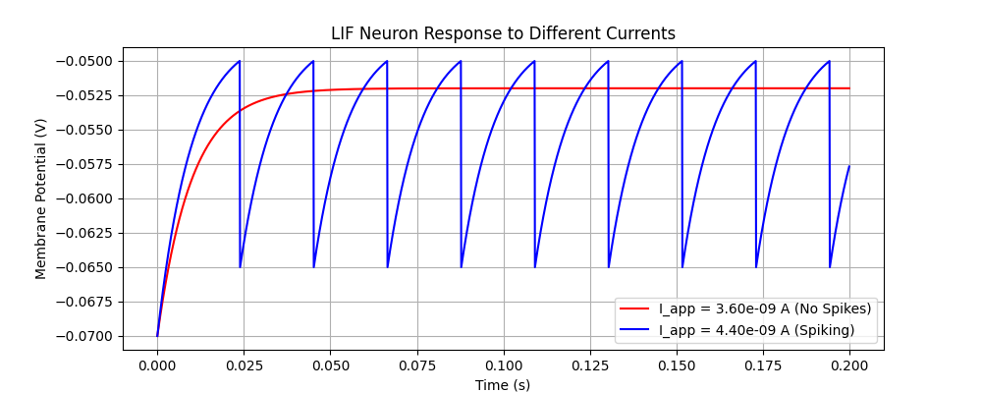

1. Make another for … end loop to use at least 10 different values of 𝐼 /44 , one value for each 2s simulation (a “trial”) such that the average firing rate (𝑓) varies in the range from 0 to 100 Hz. Plot the resulting firing rate vs. injected current (called the firing-rate curve or f-I curve).

Line 36-54  
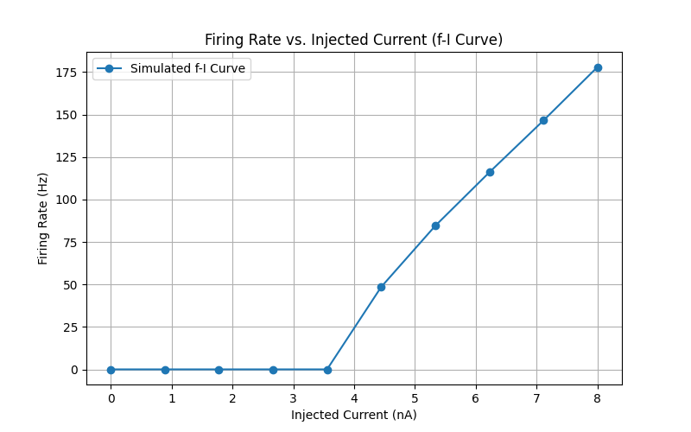

1. Compare, by plotting with different symbols on the same graph produced in 1c, the curve you obtain from the equation below for the firing rate of the neuron as you vary injected 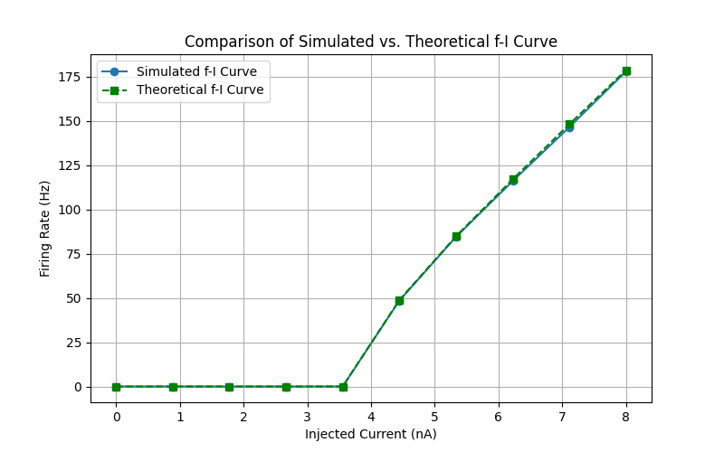current:

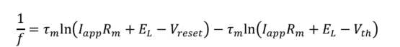

Line 56 - 73

2) a) & b) Added a noise term to the stimulation. Plotted with sigma_V values of 0, 0.05 and 0.10 V

Line 93 - 111  
c) Tested the results with different time steps: dt = 0.01, 0.05 and 0.10 ms. 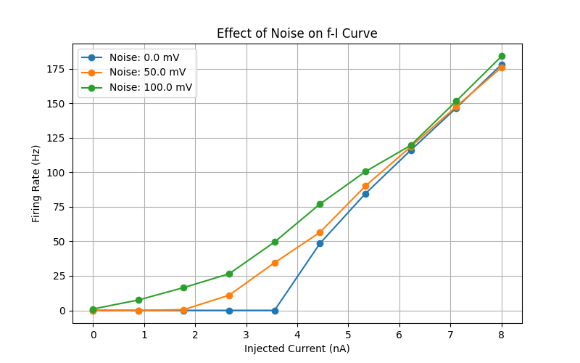

Line 113 - 133

The difference in firing rates between different time steps is negligible.

